DEPLOYING A WORDPRESS HOMEPAGE IN MONOLITHIC ARCHITECTURE

STEPS:

• Create 1 EC2 Instance and Deploy wordpress and MYSQL on that Instance.

• Configure the Security Group for your instances.

• EC2 instance type: t2-micro, and USE AMI: Ubuntu

• Create a welcome page in wordpress that will be the homepage

STEPS: 1. Log in to your AWS Management Console.

2. Navigate to the EC2 Dashboard and click on “Launch Instance”.

3. Give the instance a name like “Monolithic”

4. Select an appropriate Amazon Machine Image (AMI) based on your requirements. For this example, let's choose the latest Ubuntu Server.

5. Choose the instance type according to your needs. We'll go with a t2.micro(Free Tier) instance.

6. Configure instance details including the number of instances, network settings, and storage. Ensure to create or select a security group that permits inbound traffic on HTTP (port 80) and SSH (port 22).

7. Review the configurations and click on the “Launch Instance” button. This setup should get you started with your EC2 instance running a WordPress server on a monolithic architecture.

This setup should get you started with your EC2 instance running a WordPress server on a monolithic architecture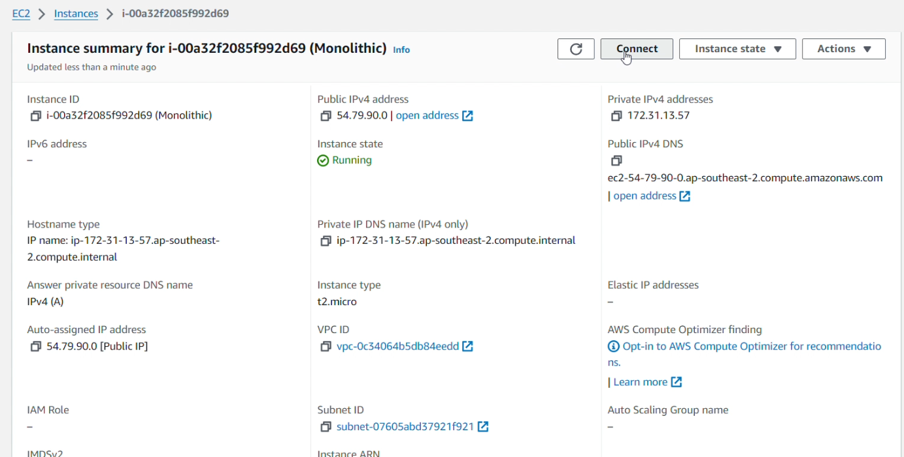

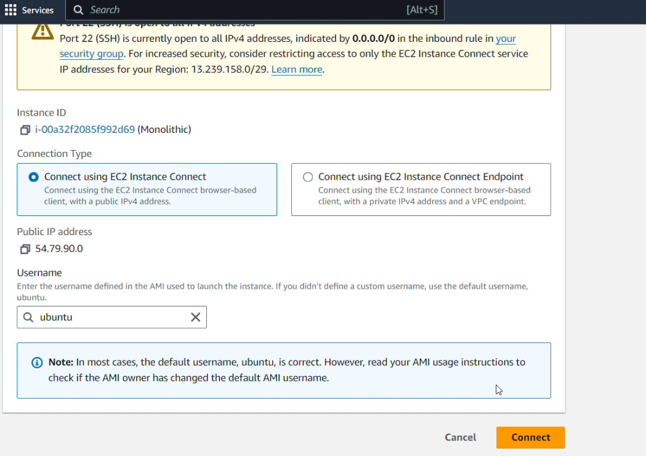

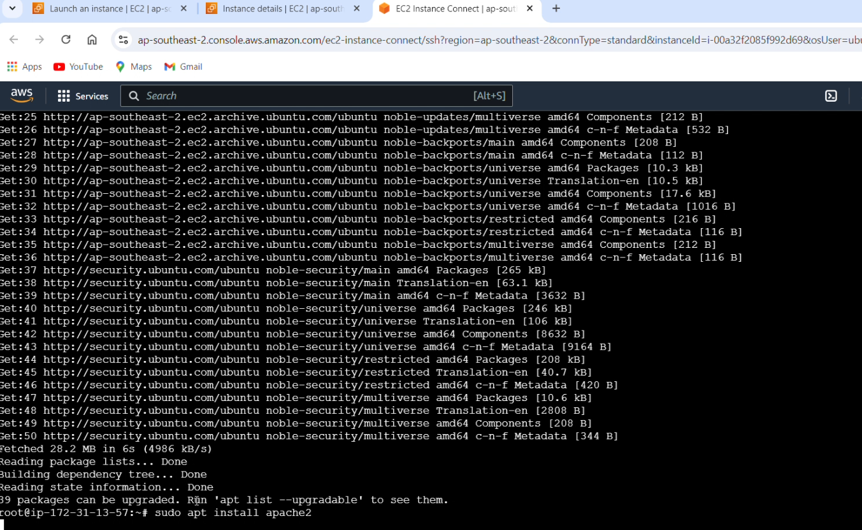

COMMANDS TO FOLLOW:

1. Install Apache server on Ubuntu:

• sudo apt update

• sudo apt install apache2

2. Install PHP runtime and PHP MySQL connector:

• sudo apt install php libapache2-mod-php php-mysql

3. Install MySQL server:

• sudo apt install mysql-server

4. Login to MySQL server:

• sudo mysql -u root

5. Change authentication plugin to mysql_native_password (change the password to something strong):

• ALTER USER 'root'@'localhost' IDENTIFIED WITH mysql_native_password by

'Akshay@123';

6. Create a new database user for WordPress (change the password to something strong):

• CREATE USER 'vaibhavi_user'@'localhost' IDENTIFIED BY ' Akshay@123';

7. Create a database for WordPress:

• CREATE DATABASE wp;

8. Grant all privileges on the database 'wp' to the newly created user:

• GRANT ALL PRIVILEGES ON wp.* TO 'wp_user'@'localhost';

• exit;

9. Download WordPress:

• cd /tmp • wget https://wordpress.org/latest.tar.gz

10. Unzip:

• tar -xvf latest.tar.gz

11. Move WordPress folder to Apache document root:

• sudo mv wordpress/ /var/www/html

12. Command to restart/reload Apache server:

• sudo systemctl restart apache2

13. Now, navigate to the WordPress directory and configure the wp-config.php file:

• cd /var/www/html/wordpress

• sudo cp wp-config-sample.php wp-config.php

• sudo vim wp-config.php Open your browser and navigate to your WordPress instance's

public IP address.

Follow the WordPress installation wizard to complete the setup.

